**DATA TECHNOLOGY SOLUTIONS**

**LAB 1B**

**GROUP A**

**PART 1: Create a test file which is more than 1.40 GB then upload it then run the command mentioned in the lecture (Slide 92 -97).**

* Create a directory under HDFS filesystem

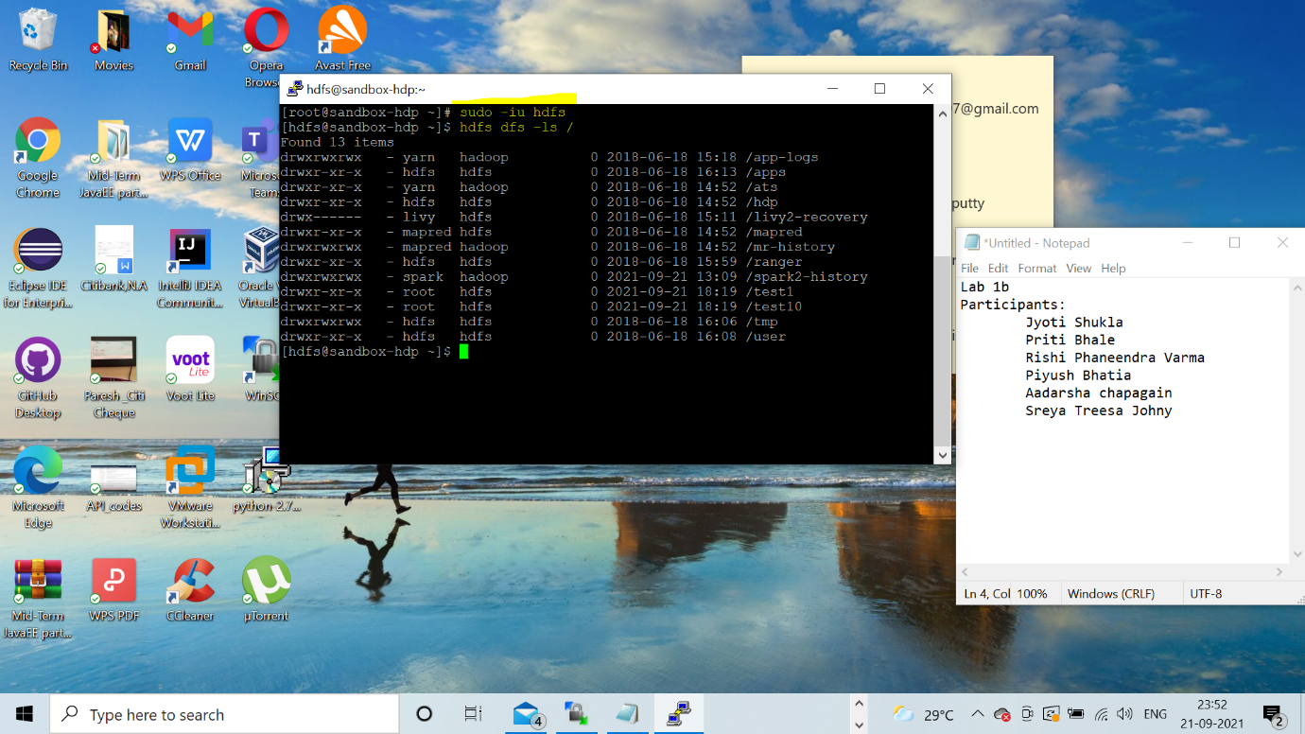

* Copy HadoopTraining_v1.0 - Copy dataset which is of 1.40GB size from local to HDP VMware using WinSCP

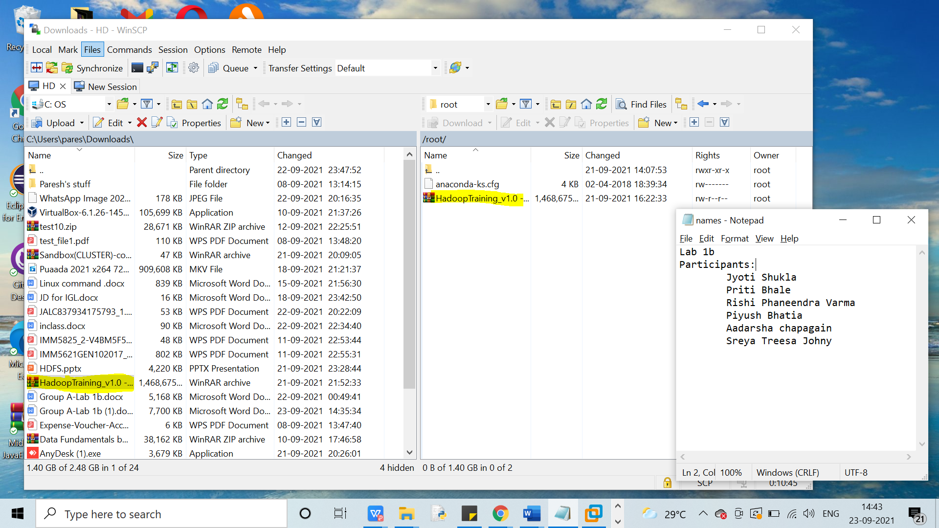

* Copy the HadoopTraining_v1.0 - Copy file from local filesystem to HDFS filesystem

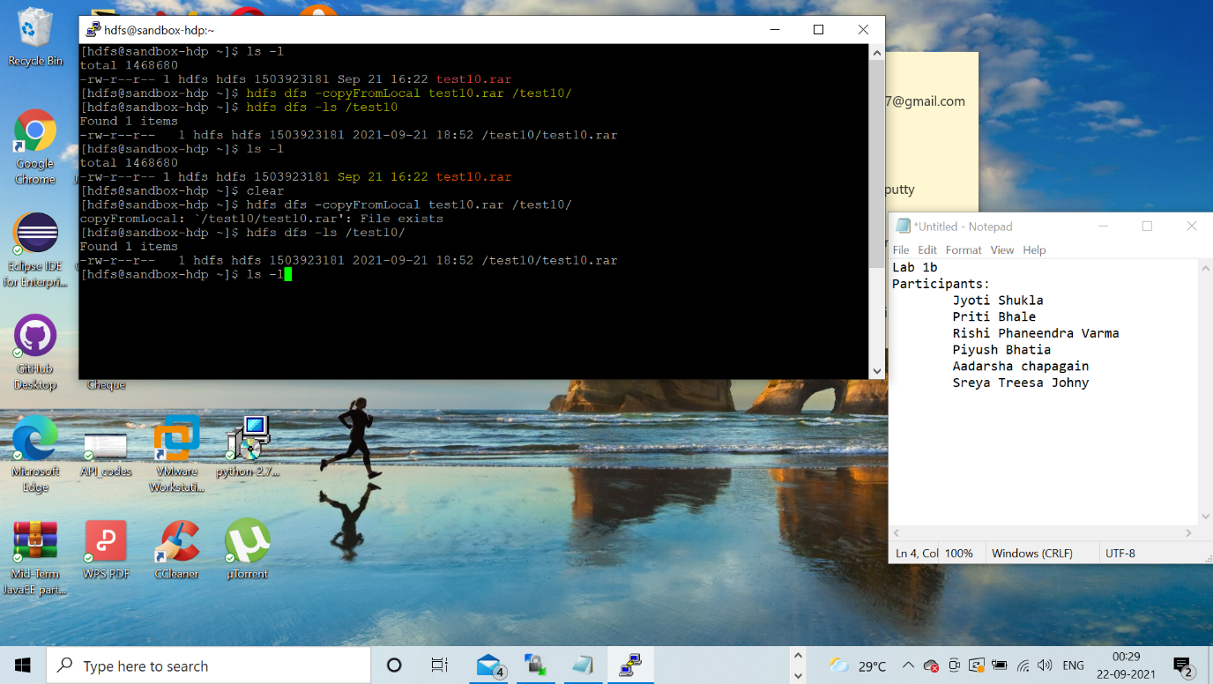

* Perform HDFS filesystem check on the new ‘HadoopTraining_v1.0 - Copy’ file .

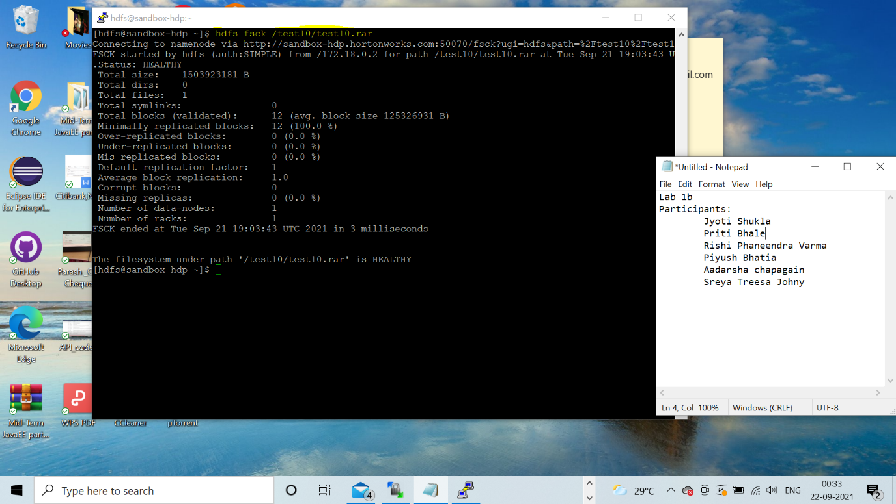

* List Corrupt file blocks If available

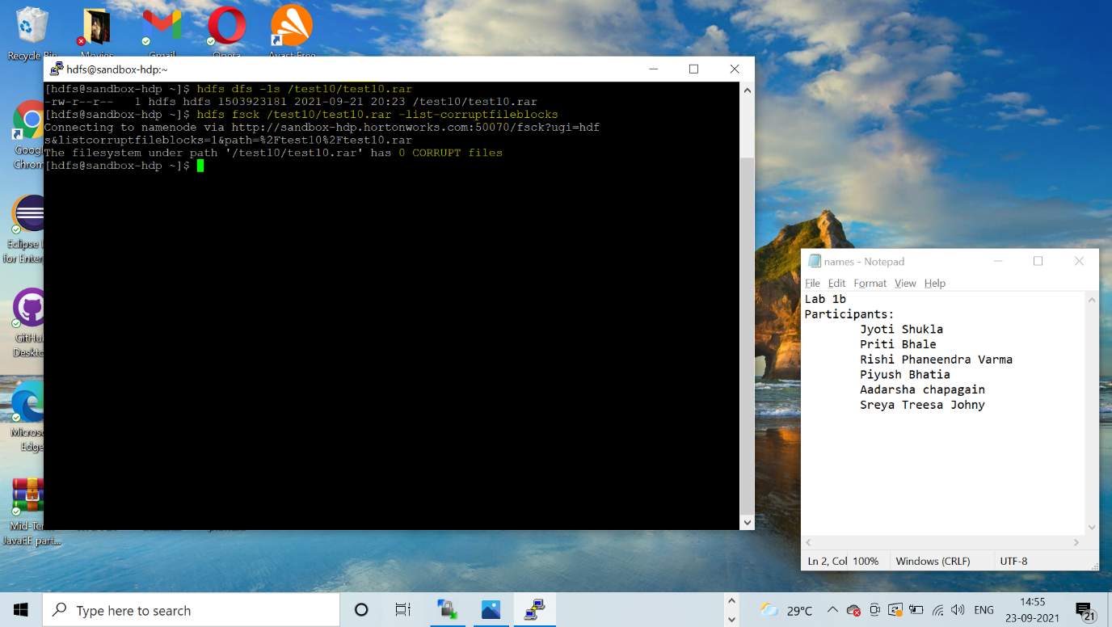

* List files and blocks of the new dataset in HDFS.

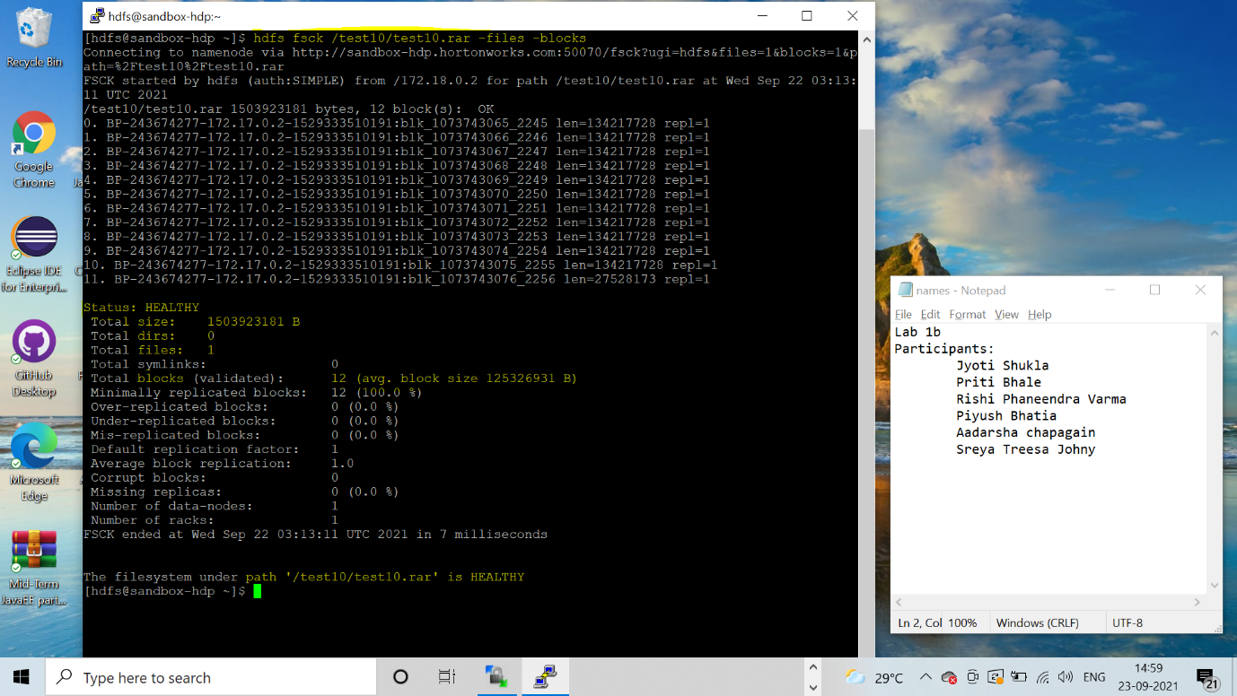

**PART 2**

**HDFS COMMANDS**

**FSCK**

1. **-files :** ‘hdfs fsck / -files’ command is used to list all the files and directories under the HDFS filesystem root directory ‘/’.

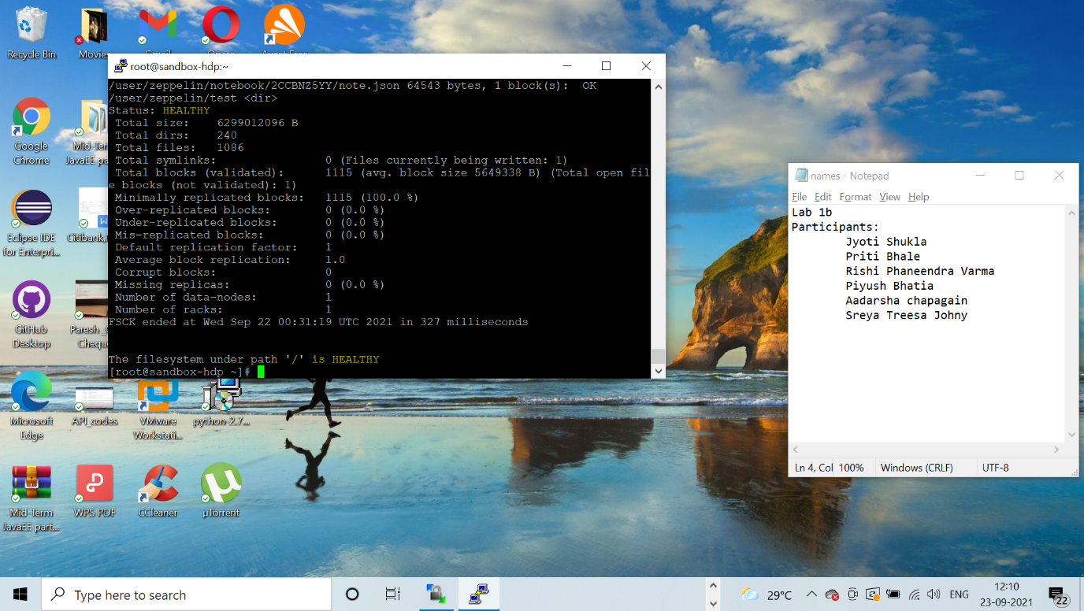

1. **-blocks :** ‘hdfs fsck / -blocks’ command is used for listing of all the blocks created for storing ‘Test10’ data. With the default block size of ‘128MB’, replication factor = 1 and the Test10 file size being 1.40GB, a total of 5 blocks are created(11 Blocks : 128MB*11 = 1408MB , 12th Block will be created by storing the remaining data of the file which is 25MB ).

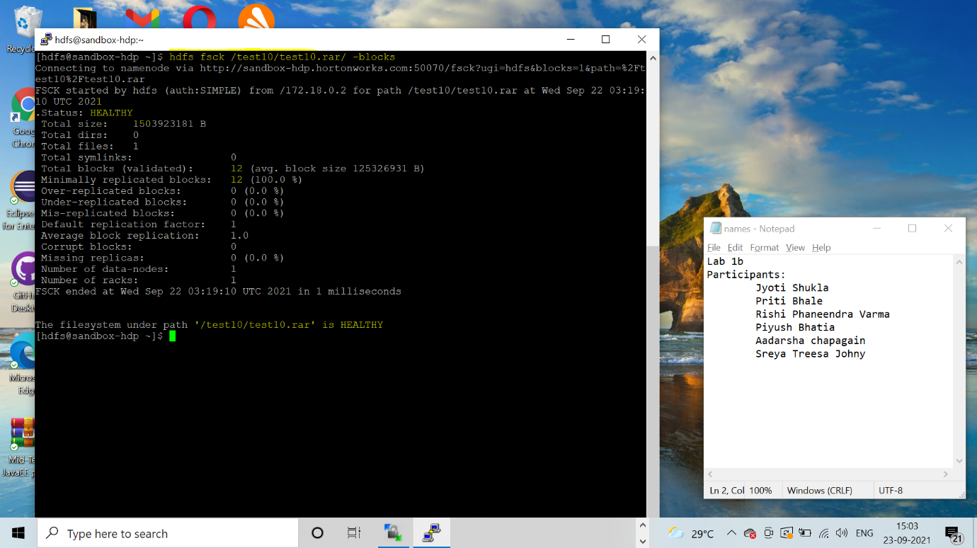

1. **-openforwrite:** ‘hdfs fsck / -openforwrite’ command is used to list all the files and directories under HDFS root directory ‘/’.

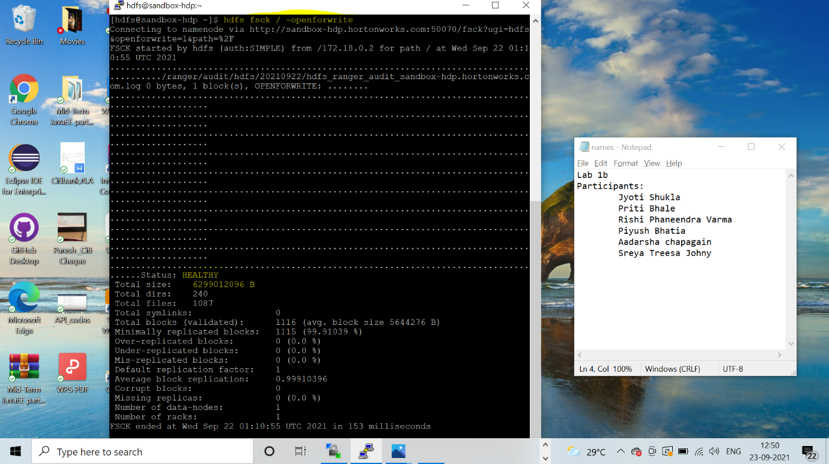

1. **-list-corruptfileblocks :** ‘hdfs fsck / --list-corruptfileblocks’ command lists all the files that are corrupted under HDFS filesystem root directory ‘/’

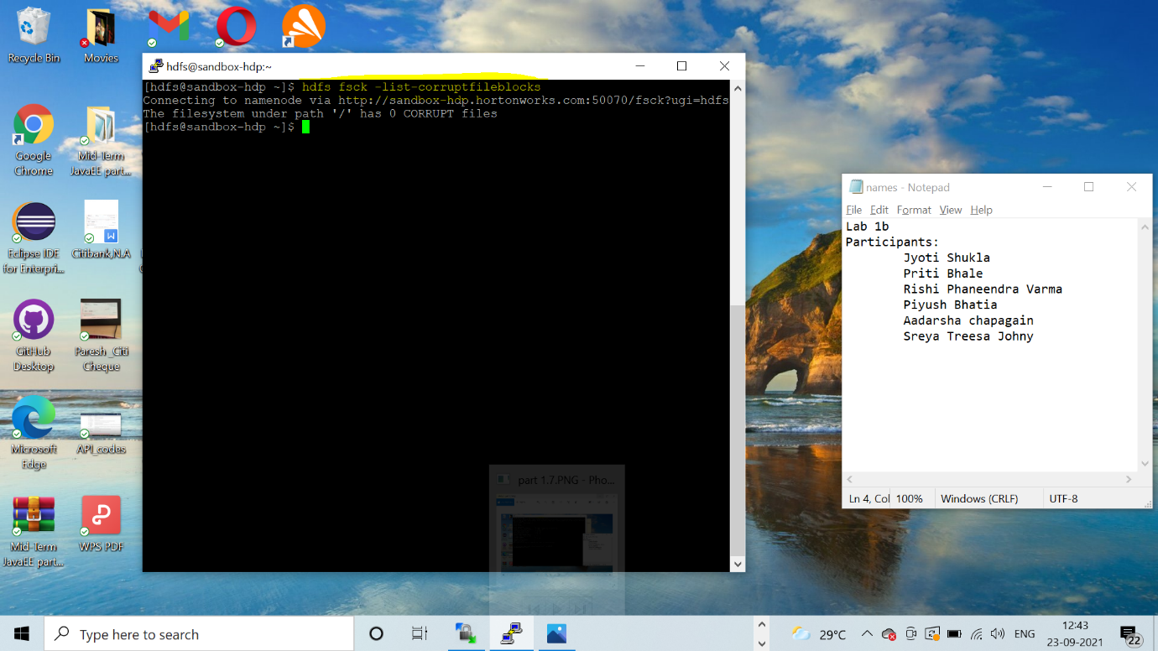

1. **-locations:** ‘hdfs fsck / -files -blocks -locations’ lists locations of the all the blocks stored across multiple datanodes. Each line represents, Block ID, Filename of the block, Block Size, replication factor, IP address of the datanode where the block is located. 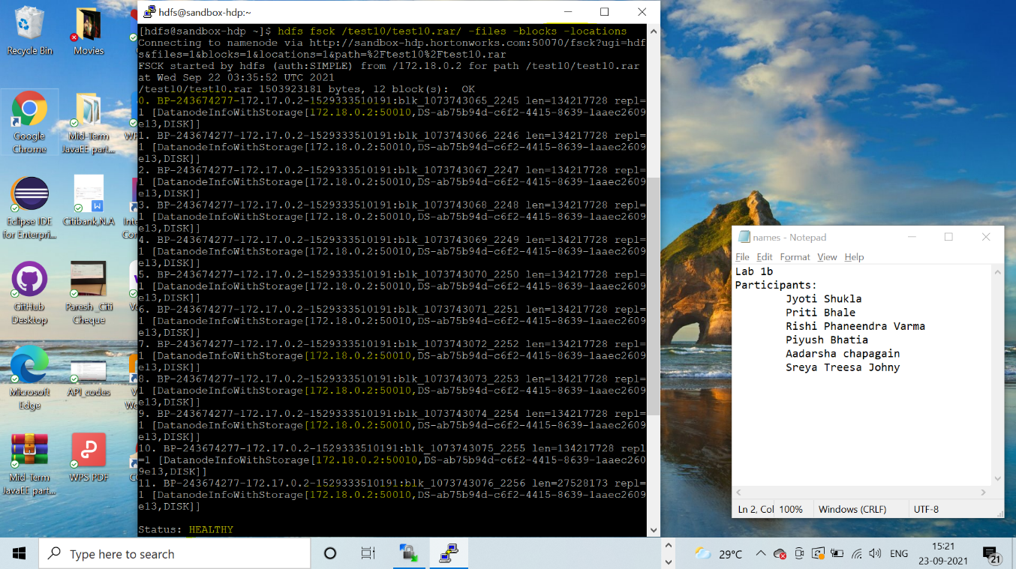

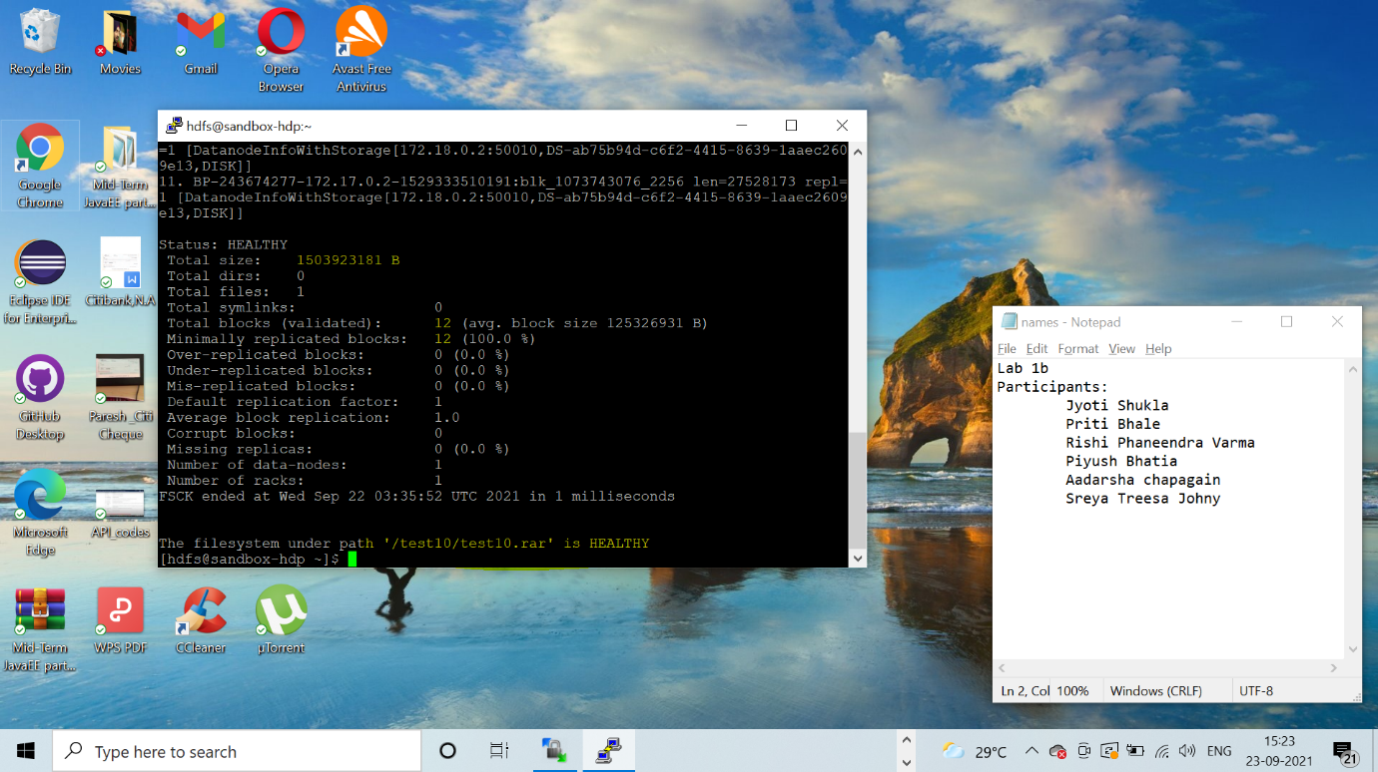

**DFS**

1. **hdfs dfs -ls / :** This command lists all the files and directories under the HDFS root filesystem ‘/’. We have created a ‘test10’ directory under / and listed using ls.

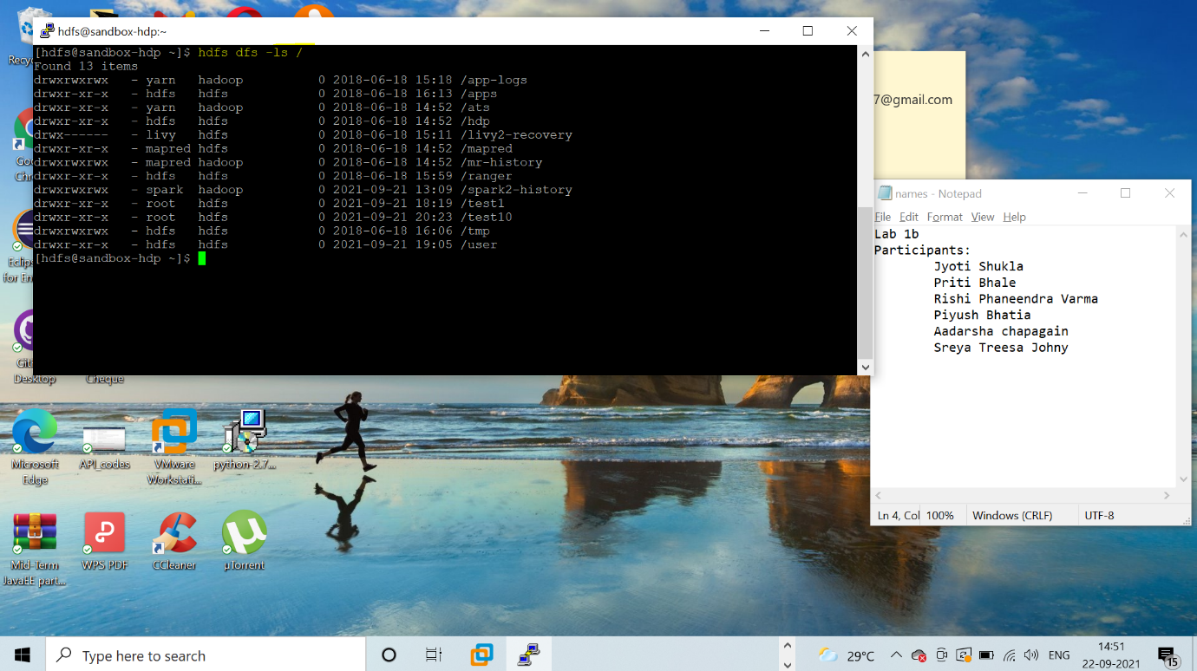

1. **hdfs dfs -mkdir :** This command is used to create a directory under HDFS filesystem root directory ‘/’. We have created a directory ‘testDir1’ under HDFS filesystem root directory.

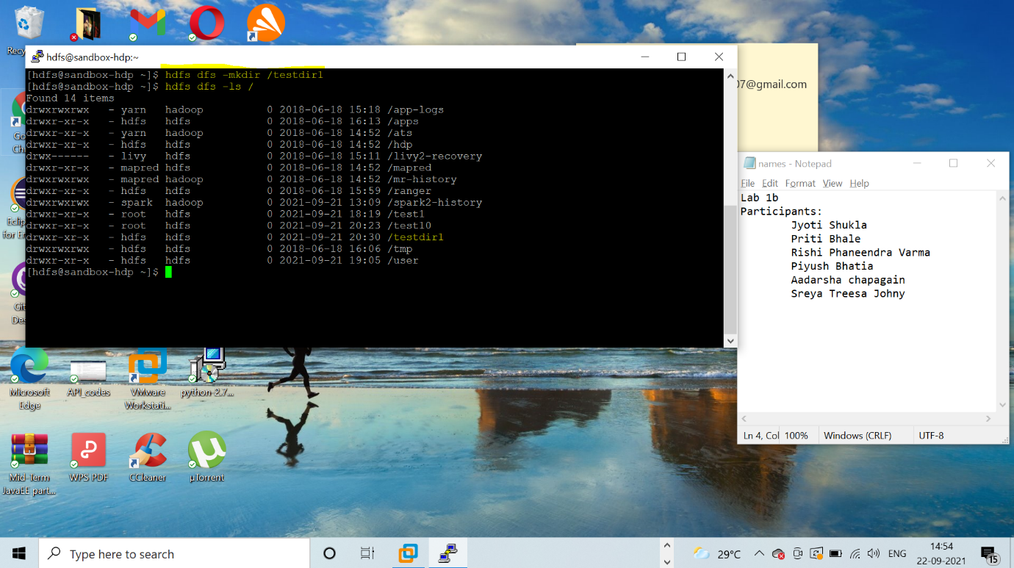

1. **hdfs dfs -copyFromLocal:** This command is used to copy files from local filesystem to HDFS filesystem. We have used a file ‘testfile21’ to copy from local to HDFS under root directory /.

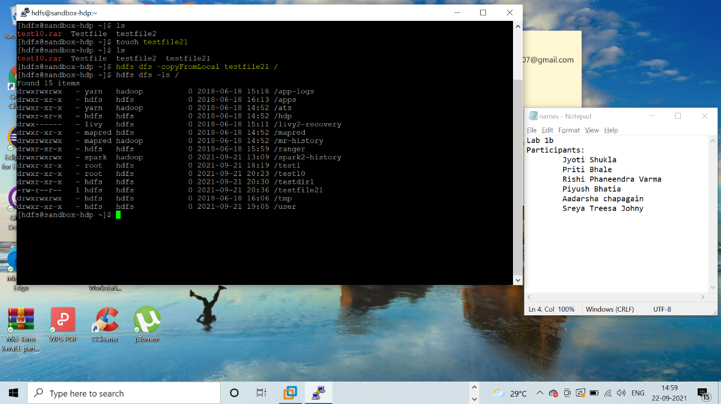

1. **hdfs dfs -touchz :** Used to create a file under HDFS filesystem. We have created a testfile21 under hdfs root directory /.

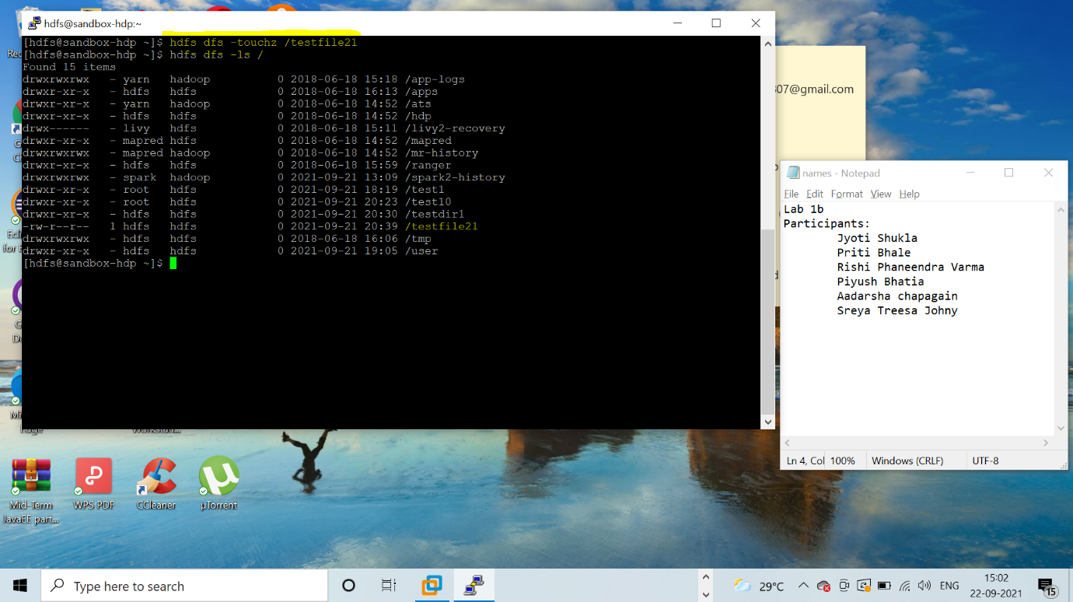

1. **hdfs dfs -copyToLocal :** Used to copy files from HDFS filesystem to local filesystem. We have copied ‘tempFile2’ from HDFS to local path ‘/home/hdoop’.

